Tables in R – A quick practical overview
by Andri Signorell
Helsana Versicherungen AG, Health Sciences, Zurich
HWZ University of Applied Sciences in Business Administration, Zurich
andri@signorell.net

February, 1th, 2021

Tabulating data in R is both, trivial and complicated. After all it is just about counting data. But the underlying data structures are diverse and technically abstract, especially when there are more than two dimensions involved. Thus, there are many functions to handle and process tables in the respective representation, which makes the situation somewhat confusing. And then there are some gaps in base R function list that are filled by DescTools.
This document aims to briefly summarise, how to create, manipulate and describe count data in tables. Some examples from the SAS-documentation FREQ are reproduced.

1 Starting Point 2
2 Create Table 3
2.1 Creating from the scratch 3
2.2 Building categories from a numeric variable 4
2.3 Expanding 5
2.4 SAS datalines 5
3 Tabulate 5
4 Reorganize 7
5 Aggregate 9
6 Append 10
7 Convert 10
8 Print and Format 11
9 Export 12
10 Plot 13
11 Save 14
12 Descriptions, Statistics and Tests 14
13 Cases 19
13.1 Eye colour - Binomial Proportions for One-Way Frequency Tables 19
13.2 Cochran-Armitage Trend Test 20
13.3 Heart – 2x2-Table 20
13.4 Skin - Agreement Study 23
13.5 Migraine - Statistics for a Stratified 2x2-Table 23
14 References 26

Note: For all the examples in this document, library(DescTools) must be declared.

Starting Point
The analysis of categorical data usually starts with tables. In R we have a comprehensive (but not complete) toolset to work with tables of two and more dimensions. Thus, there’s room for extensions with functions useful in the analyst’s daily life. The package DescTools contains a fair number of additional functions, which are described in this document.

The first question is how categorical data is technically organised. Normally it will be given in one of the following three data structures.

A) Single case | B) Frequency | C) Table
The raw data in form of a data frame (or a matrix), each row contains one case, here one person: | Unique combinations of factors extended with their counts, often called weights (column “Freq”): | A multidimensional table  (or an array, matrix):
Untable(UCBAdmissions)  Admit Gender Dept  1 Admitted Male A  2 Admitted Male A  3 Admitted Male A  4 Admitted Male A  5 Admitted Male A  6 Admitted Male A  7 Admitted Male A ...  511 Admitted Male A  512 Admitted Male A  513 Rejected Male A  514 Rejected Male A  ... | data.frame(UCBAdmissions)  Admit Gender Dept Freq  1 Admitted Male A 512  2 Rejected Male A 313  3 Admitted Female A 89  4 Rejected Female A 19  5 Admitted Male B 353  6 Rejected Male B 207  7 Admitted Female B 17  8 Rejected Female B 8  9 Admitted Male C 120  10 Rejected Male C 205  11 Admitted Female C 202  12 Rejected Female C 391  12 Rejected Female C 391  ... | UCBAdmissions  , , Dept = A  Gender  Admit Male Female  Admitted 512 89  Rejected 313 19  , , Dept = B  Gender  Admit Male Female  Admitted 353 17  Rejected 207 8  , , Dept = C  ...
Either we have the raw data arranged case-by-case in a data frame (case A). Then a contingency table can be built by tabulating the data. There are several commands for this described in chapter “Tabulate”.
Or the data are given as a combination of factor levels and one count variable (typically organized as a data frame too) (case B). The first line in this representation means, that we have 512 men admitted to department A in our sample. This corresponds to the cell [1, 1, 1] in the representation C). In representation A we would have 512 rows with the exactly same content, namely Admitted/Male/A.
How to directly create such a structure is described in “Expanding”. There are functions to convert this structure to a table or to recreate the raw dataset. This is detailed in the chapter “Convert”.
When the data are given directly as a table (case C), there are again several ways how to enter that into R. This is the content of the first chapter “Create tables”.
How to process tables is described in the chapters “Reorganize”, “Aggregate”, “Append”, “Convert”.

Usually B) will be the most economic representation of frequency data whereas the case-by-case form in A) is the least (provided the data set is purely categorical). The built-in data sets from the R base system that are purely categorical usually come in the form of tables (C).

Create Table

Creating from the scratch
There are several ways to enter contingency table data into R. Let’s illustrate here some approaches with a table concerning party affiliation by gender:

Table 2.1 Tabulating Party versus Gender, Agresti (2007) p. 39
Gender | Party
 | Democrat | Independent | Republican
M | 762 | 327 | 468
F | 484 | 239 | 477

The first approach uses the function rbind and builds a matrix row by row. The as.table() function lets R know that the matrix represents a contingency table of counts:
rbind
as.table

tab <- as.table(rbind(c(762, 327, 468), c(484, 239, 477)))
dimnames(tab) <- list(gender = c("M", "F"),
party = c("Democrat", "Independent", "Republican"))
tab

## party
## gender Democrat Independent Republican
## M 762 327 468
## F 484 239 477

The exactly same result can be created by the second approach, using the function matrix. Note that, by default, matrix() uses the elements supplied by columns in the result, unless you specify byrow=TRUE.
matrix

as.table(matrix(c(762, 327, 468, 484, 239, 477), nrow=2, byrow=TRUE,
dimnames=list(gender= c("M", "F"),
party = c("Democrat", "Independent", "Republican"))))

The third way uses TextToTable to convert a text to a table. Within this function read.table is used to enter the data and to convert the data frame to a table. header=TRUE will take the names of the variables from its first line.
TextToTable
The column names and row names will automatically be chosen, if the first row contains one fewer field than the number of columns. The dimension names can be provided with the specific argument:

txt <- "
Democrat, Independent, Republican
M, 762, 327, 468
F, 484, 239, 477"

TextToTable(txt, sep=",", dimnames=c("gender", "party"))
Higher dimensional arrays can be defined with the function array by using the argument dim:
array

salary <- array(
, , salary = >=1000

disease
exposure case control
exposed 12 136
not 9 383
c(38, 12, 102, 141, 12, 9, 136, 383),
3
2
dim=c(2, 2, 2),
dimnames=list(exposure = c("exposed", "not"),
dim
disease = c("case", "control"),
salary = c("<1000", ">=1000"))
, , salary = <1000

disease
exposure case control
exposed 38 102
not 12 141
)

Note how the dimensions are organised:
1
The first dimension corresponds to the rows,
the second to the columns, the third to the depth, and so on.

Figure 2.1 3-dimensional table

Higher dimensional tables condensed in flat tables with more than one column, resp. row variable, can be created from the appropriate text chunk by means of the base function read.ftable. (Beware not to insert spaces at the beginning of the lines.)
read.ftable

txt <-
" Sex Male Female
Eye Brown Blue Hazel Green Brown Blue Hazel Green
Hair
Black 32 11 10 3 36 9 5 2
Brown 53 50 25 15 66 34 29 14
Red 10 10 7 7 16 7 7 7
Blond 3 30 5 8 4 64 5 8
"
tab <- as.table(read.ftable(textConnection(txt)))

Building categories from a numeric variable
When a numeric variable has to be cut into intervals there’s the function hist() for creating a histogram. The DescTools function Freq() is designed to give the numeric representation of a histogram. It displays the frequencies and the percentages of a binned variable with the same default logic as hist(). The single and cumulative frequencies values are reported.

Freq(d.pizza$temperature)
Freq
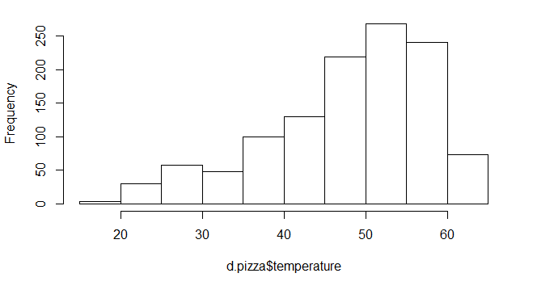
## level freq perc cumfreq cumperc
## 1 [15,20] 3 0.3% 3 0.3%
## 2 (20,25] 30 2.6% 33 2.8%
## 3 (25,30] 58 5.0% 91 7.8%
## 4 (30,35] 48 4.1% 139 11.9%
## 5 (35,40] 100 8.5% 239 20.4%
## 6 (40,45] 130 11.1% 369 31.5%
## 7 (45,50] 219 18.7% 588 50.3%
## 8 (50,55] 268 22.9% 856 73.2%
## 9 (55,60] 241 20.6% 1097 93.8%
## 10 (60,65] 73 6.2% 1170 100.0%
hist
hist(d.pizza$temperature)
Figure 2.2 Histogram of a numeric variable.

Expanding
For small frequency tables, it is often convenient to enter them in frequency form using expand.grid() for the factors and c() to list the counts in a vector.
expand.grid
tab <- data.frame(expand.grid(
Hair = c("Black", "Brown", "Red", "Blond"),
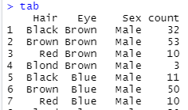
Eye = c("Brown", "Blue", "Hazel", "Green"),
Sex = c("Male", "Female")),
count = c(32,53,10,3,11,50,10,30,10,25,7,5,3,15,7,8,
36,66,16,4,9,34,7,64,5,29,7,5,2,14,7,8) )

expand.grid will create all the interactions between the given
factors, whereas the first factors vary fastest. data.frame will
bind them with the count variable, denominating the number of observations. This will be a type B representation of count data, which can be converted with xtabs to a table. (See Chapter “Convert”)

SAS datalines
Longstanding predominance of SAS entails, that small data tables in examples and documents are often reported in the SAS datalines format. Creating a table based on this in R is not straight forward, as there might be more than one case per row (as in the example below).
The function ParseSASDatalines parses the syntax and creates a table named after the data statement, using given column names (specified by the keyword input).

ParseSASDatalines("
ParseSAS-
Datalines
data SummerSchool;
input Gender $ Internship $ Enrollment $ Count @@;
datalines;
boys yes yes 35 boys yes no 29
boys no yes 14 boys no no 27
girls yes yes 32 girls yes no 10
girls no yes 53 girls no no 23
;")

The command above will directly (and silently) create a new data object named SummerSchool in the GlobalEnvironment.

Tabulate
The built-in data set HairEyeColor has the class table. Let’s turn this table into a case-by-case data frame as a base for the subsequent analysis. Untable does this job.

d.col <- Untable(HairEyeColor)
Untable
head(d.col, 3)

## Hair Eye Sex
## 1 Black Brown Male
## 2 Black Brown Male
## 3 Black Brown Male

From here we can start tabulating again. The simplest case is to tabulate a single vector. The function table yields the absolute frequencies and prop.table the proportions:
table
prop.table

table(d.col$Hair)  ## Black Brown Red Blond  ## 108 286 71 127 | prop.table(table(d.col$Hair))  ## Black Brown Red Blond  ## 0.1824324 0.4831081 0.1199324 0.2145270

A combination of both extended with the cumulative sums for both, absolute and relative frequencies, can be produced by Freq (here ordered by decreasing frequency):

Freq(d.col$Hair, ord="desc")
Freq

## level freq perc cumfreq cumperc
## 1 Brown 286 48.3% 286 48.3%
## 2 Blond 127 21.5% 413 69.8%
## 3 Black 108 18.2% 521 88.0%
## 4 Red 71 12.0% 592 100.0%

By means of the table function we can produce multidimensional contingency tables (aka. crosstabs) as well. We use the command with here, so we can avoid having to qualify every column name with the name of the data.frame (which makes the code more readable).

with(d.col, table(Hair, Eye))

## Eye
## Hair Brown Blue Hazel Green
## Black 68 20 15 5
## Brown 119 84 54 29
## Red 26 17 14 14
## Blond 7 94 10 16

The first entered variable will be the row variable, the second one the column variable. Missing values are ignored by default. In order to include NA as a category in counts, use the option useNA="always".
A relative frequency table can be produced using the function prop.table, which takes a table object as argument:

with(d.col, prop.table(table(Hair, Eye), margins=NULL))

## Eye
## Hair Brown Blue Hazel Green
## Black 0.114864865 0.033783784 0.025337838 0.008445946
## Brown 0.201013514 0.141891892 0.091216216 0.048986486
## Red 0.043918919 0.028716216 0.023648649 0.023648649
## Blond 0.011824324 0.158783784 0.016891892 0.027027027

The function PercTable combines that and allows adding marginal sums in one step:

PercTable(Hair ~ Eye, data=d.col, rfrq="111", margins=c(1,2))
PercTable
## Eye Brown Blue Hazel Green Sum
## Hair
##
## Black freq 68 20 15 5 108
## perc 11.5% 3.4% 2.5% 0.8% 18.2%
## p.row 63.0% 18.5% 13.9% 4.6% .
## p.col 30.9% 9.3% 16.1% 7.8% .
##
## Brown freq 119 84 54 29 286
## perc 20.1% 14.2% 9.1% 4.9% 48.3%
## p.row 41.6% 29.4% 18.9% 10.1% .
## p.col 54.1% 39.1% 58.1% 45.3% .
##
## Red freq 26 17 14 14 71
## perc 4.4% 2.9% 2.4% 2.4% 12.0%
## p.row 36.6% 23.9% 19.7% 19.7% .
## p.col 11.8% 7.9% 15.1% 21.9% .
##
## Blond freq 7 94 10 16 127
## perc 1.2% 15.9% 1.7% 2.7% 21.5%
## p.row 5.5% 74.0% 7.9% 12.6% .
## p.col 3.2% 43.7% 10.8% 25.0% .
##
## Sum freq 220 215 93 64 592
## perc 37.2% 36.3% 15.7% 10.8% 100.0%
## p.row . . . . .
## p.col . . . . .

There are more options, as expected values or standard residuals, which can optionally be integrated.

The marginal tables can be produced by R base function margin.table or by the somewhat extended function Margins in DescTools:

Margins(tab, ord="desc")
Margins

## $Hair  ## level freq perc cumfreq cumperc  ## 1 Brown 286 0.483 286 0.483  ## 2 Blond 127 0.215 413 0.698  ## 3 Black 108 0.182 521 0.880  ## 4 Red 71 0.120 592 1.000 | ## $Eye  ## level freq perc cumfreq cumperc  ## 1 Brown 220 0.372 220 0.372  ## 2 Blue 215 0.363 435 0.735  ## 3 Hazel 93 0.157 528 0.892  ## 4 Green 64 0.108 592 1.000
table does not come with a formula interface, but the xtabs function does. This allows us to create multidimensional crosstabulations using formula style input. The result is a contingency table in array format, whose dimensions are determined by the terms on the right side of the formula.

Reorganize
Say we created a three dimensional table with Hair, Eye and Sex as variables and typically got a 3-dim array as result. This will be displayed as:

(tab <- with(d.col, table(Hair, Eye, Sex)))

## , , Sex = Male  ##  ## Eye  ## Hair Brown Blue Hazel Green  ## Black 32 11 10 3  ## Brown 53 50 25 15  ## Red 10 10 7 7  ## Blond 3 30 5 8 | ##, , Sex = Female  ##  ## Eye  ## Hair Brown Blue Hazel Green  ## Black 36 9 5 2  ## Brown 66 34 29 14  ## Red 16 7 7 7  ## Blond 4 64 5 8  ##

To combine this multidimensional structure into a flat table while preserving all the details, there’s the function ftable. The variables to be placed in the rows can be defined by the argument row.vars, which can be a vector (denoting multiple dimensions) containing the dimension numbers or the names, if there are any defined.
ftable
So to put Eye (variable 2) and Sex (variable 3) in the rows and Hair as column variable, we can use both, subscripts or dimension names, writing

ftable(tab, row.vars = c(2, 3))
ftable(tab, row.vars = c("Eye", "Sex"))

## Hair Black Brown Red Blond
## Eye Sex
## Brown Male 32 53 10 3
## Female 36 66 16 4
## Blue Male 11 50 10 30
## Female 9 34 7 64
## Hazel Male 10 25 7 5
## Female 5 29 7 5
## Green Male 3 15 7 8
## Female 2 14 7 8

The tab, as we constructed it, has the Hair as rows (1), the Eye as columns (2), and the Sex as third dimension (3) defined. The dimensions and dimension names follow the defined order:

dimnames(tab)

## $Hair
## [1] "Black" "Brown" "Red" "Blond"
##
## $Eye
## [1] "Brown" "Blue" "Hazel" "Green"
##
## $Sex
## [1] "Male" "Female"

If we have to change the order of the dimensions, we can make use of the base-R function aperm. Let’s say we wanted Eye as row variable and Sex a column variable and consequently Hair as 3th variable, we can tell aperm to set dimension 2 on the first position, 3 on the second and 1 on the third position. So we get:
aperm

aperm(tab, c(2,3,1))

##, , Hair = Black  ##  ## Sex  ## Eye Male Female  ## Brown 32 36  ## Blue 11 9  ## Hazel 10 5  ## Green 3 2  ## | ##, , Hair = Brown  ##  ## Sex  ## Eye Male Female  ## Brown 53 66  ## Blue 50 34  ##  ...

The following would by the way not work:

tab["Eye", "Sex", "Hair"]
Error in tab["Eye", "Sex", "Hair"] : subscript out of bounds

To reorder the sequence of the levels (within a dimension) in our table, we could use reorder.factor. Say we would like to have the sequence Blue, Green, Hazel, Brown for the Eye colour. Of course, when having the raw data, we would use
factor(d.col$Eye, levels=c("Blue", "Green", "Hazel", "Brown"))
and any table afterwards would inherit this level order. But how can we change this in an already created table? The answer is obvious (but may yet be unexpected in this context): Use the subscript! This works with the level names as well as with the index positions.

tab[ , c("Blue", "Green", "Hazel", "Brown"), ]

## , , Sex = Male  ##  ## Eye  ## Hair Blue Green Hazel Brown  ## Black 11 3 10 32  ## Brown 50 15 25 53  ## Red 10 7 7 10  ## Blond 30 8 5 3  ## | ## , , Sex = Female  ##  ## Eye  ## Hair Blue Green Hazel Brown  ## Black 9 2 5 36  ## Brown 34 14 29 66  ## Red 7 7 7 16  ## Blond 64 8 5 4

For simply reversing the levels there’s the function Rev, which has a table interface implemented. The function accepts a margins argument, defining the dimensions whose levels should be reversed. Compare the reversed levels of Hair and Sex:
Rev

tab  ## , , Sex = Male  ##  ## Eye  ## Hair Brown Blue Hazel Green  ## Black 32 11 10 3  ## Brown 53 50 25 15  ## Red 10 10 7 7  ## Blond 3 30 5 8  ##  ## , , Sex = Female  ##  ## Eye  ## Hair Brown Blue Hazel Green  ## Black 36 9 5 2  ## Brown 66 34 29 14  ## Red 16 7 7 7  ## Blond 4 64 5 8 | Rev(tab, margin = c(1, 3))  ## , , Sex = Female  ##  ## Eye  ## Hair Brown Blue Hazel Green  ## Blond 4 64 5 8  ## Red 16 7 7 7  ## Brown 66 34 29 14  ## Black 36 9 5 2  ##  ## , , Sex = Male  ##  ## Eye  ## Hair Brown Blue Hazel Green  ## Blond 3 30 5 8  ## Red 10 10 7 7  ## Brown 53 50 25 15  ## Black 32 11 10 3
Renaming level names can be achieved by refining the dimension names.
dimnames(tab)$Sex <- c("men", "women")

Aggregate
Sometimes we might want to aggregate an existing table along one or several dimensions. Say we’d like to get rid of the Hair dimension but retain all the frequency information for the other dimensions. For this we can use apply as we would in the case of a matrix. The function takes vectors as well for the margins. The order of the subscripts specified in the apply statement determines the order of the subscripts in the result.
So, if we sum up all cases along the 1st dimension (Hair) and retain the other two (2, 3) we would get:
apply
apply(tab, c(2,3), sum)  ## Sex  ## Eye Male Female  ## Brown 98 122  ## Blue 101 114  ## Hazel 47 46  ## Green 33 31 | apply(tab, 1, sum)  ## Black Brown Red Blond  ## 108 286 71 127
This works with the dimension names too: apply(tab, c("Eye", "Sex")) will deliver the same result.
Single margins could be calculated correspondingly, as demonstrated above.

If tab was created with xtabs, it can be aggregated directly by using the formula interface, which typically is clearer and more readable.
xtabs

xtab <- xtabs(~., d.col)
xtabs(Freq ~ Eye + Sex, xtab)

## Sex
## Eye Male Female
## Brown 98 122
## Blue 101 114
## Hazel 47 46
## Green 33 31

If we want to combine some levels, we can with CollapseTable. Say we want to fuse brown and hazel eyes to a new category Browny, as well as just having two groups of Hair, namely Dark and Fair:
CollapseTable

CollapseTable(tab, Eye=c("Browny","Blue","Browny","Green"),
Hair=c("Dark","Dark","Fair","Fair"))

## , , Sex = Male  ##  ## Eye  ## Hair Browny Blue Green  ## Dark 120 61 18  ## Fair 25 40 15 | ##, , Sex = Female  ##  ## Eye  ## Hair Browny Blue Green  ## Dark 136 43 16  ## Fair 32 71 15

Append
Sometimes we need to paste tables together, for instance when two tables of the same dimension should be put together to a 3-dimensional array. In contrast to the 2-dimensional case, where the functions rbind and cbind exist, base R does not contain a respective function for higher dimensional tables. In DescTools there’s the function Abind included for this purpose (indeed borrowed from the abind package).

a <- HairEyeColor[,,1] # male table
b <- HairEyeColor[,,2] # female table

Abind(Male=a, Female=b, along=3)
Abind

## , , Male  ##  ## Brown Blue Hazel Green  ## Black 32 11 10 3  ## Brown 53 50 25 15  ## Red 10 10 7 7  ## Blond 3 30 5 8  ## | ## , , Female  ##  ## Brown Blue Hazel Green  ## Black 36 9 5 2  ## Brown 66 34 29 14  ## Red 16 7 7 7  ## Blond 4 64 5 8

The first step separates the table for males from the females. Abind reverses this step and binds the two tables together again. This can happen along all possible dimensions.
In the example above a new dimension is introduced by setting along = 3.
Abind(a,b,along=2) would bind the tables by columns (as cbind does), whereas Abind(a,b,along=1) would give the same result as rbind(a,b).

Convert
Time and again newbies wonder how to convert tables from one to the other form. Base R comprises most of the required functions, but not quite all.
Let’s say we have the three forms of table given as:
A) d.col <- Untable(HairEyeColor) # case-by-case
B) d.weight <- as.data.frame(HairEyeColor) # frequency
C) tab <- HairEyeColor # table

The conversions can be made as follows.

case-by-case
frequency
table
A) B) | 1) as.data.frame(table(d.col))  2) aggregate(rep(1, nrow(d.col)),  by=d.col, FUN=length) | This is actually A) to C) to B)!  Solution 2) will yield the nonzero entries only.  as.data.frame  aggregate  Untable  xtabs
A) B) | Untable(d.weight) | library(DescTools)
A) C) | table(d.col)
A) C) | Untable(tab)
B) C) | xtabs(Freq ~ ., d.weight)
B) C) | as.data.frame(tab) | If tab is defined as matrix, as.data.frame has to be specified explicitly as as.data.frame.table!

The conversion of an xtabs object to a matrix would normally not be carried out in base R. The class would remain (“xtabs”, “table”) after calling the as.matrix() function. All attributes won’t be touched as well.

str(as.matrix(htab))
## xtabs [1:2, 1:7] 119 1070 16 60 12 14 7 4 3 0 ...
## - attr(*, "dimnames")=List of 2
## ..$ race : chr [1:2] "Black" "White"
## ..$ nvics: chr [1:7] "0" "1" "2" "3" ...
## - attr(*, "class")= chr [1:2] "xtabs" "table"
## - attr(*, "call")= language xtabs(formula = freq ~ race + nvics,
data = homicide)

We hold the view that if we order a matrix with as.matrix(), we should receive one (and nothing else). DescTools will add an xtabs interface for as.matrix() such, that the class and call attributes will be adapted.

library(DescTools)

str(as.matrix(htab))
## num [1:2, 1:7] 119 1070 16 60 12 14 7 4 3 0 ...
## - attr(*, "dimnames")=List of 2
## ..$ race : chr [1:2] "Black" "White"
## ..$ nvics: chr [1:7] "0" "1" "2" "3" ...

Print and Format
All table connected classes have their print methods which do not call for any further explanation. There are several approaches out there, how to turn tables into XML, HTML or LATEX. DescTools contains two functions for sending tables to MS-Word. WrdTable would create the table in Word and transfer the cell information appropriately.

Let’s create an artificial table, with one cell being 0 and one being NA. Then we format the counts with a big.mark and set 0 digits. The zero values should be expressed as “-“ and the NAs as “missing”. Finally, all should be aligned to the right.

(tab <- as.table(matrix(c(2000, 0, 34, NA), nrow=2)))
## A B
## A 2000 34
## B 0

tab[] <- Format(tab, big.mark = "'", digits=0, zero.form="-", na.form="Missing")
Format
tab[] <- StrAlign(tab, "\\r") # right alignement
tab

## A B
## A 2'000 34
## B - Missing

The counts and percentages in PercTable can be formatted by setting the options fmt.abs and fmt.per. The percentages are formatted as .000 and the counts with a space for big.mark.

options(fmt.abs=structure(list(digits=1, big.mark=" "), class="fmt"))
options(fmt.per=structure(list(digits=3, leading="drop"), class="fmt"))
PercTable(tab)

## A B
##
## A freq 2 000.0 34.0
## perc .720 .012
##
## B freq 0.0 745.0
## perc .000 .268

Note that by applying formats to the cells, the numeric values turn to strings and cannot be subsequently used for further calculating.

FixToTab is trying to chop the fixed font output of a table given as text to a tab delimited table.

Export
DescTools contains functions for exporting tables to Word or Excel. Exporting to Excel would at least handle “ftables” adequately.

tab <- ftable(HairEyeColor, col.vars = c("Sex", "Hair"))
XLView
XLView(tab)

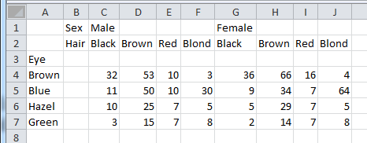
Figure 9.1 Excel sheet containing exported table from R.

The Word-Interface is already somewhat more elaborated (but still unsatisfactory):
WrdTab
ToWrd (tab, wrd=GetNewWrd())

Sex | Male |  |  |  | Female
Hair Eye | Black | Brown | Red | Blond | Black | Brown | Red | Blond
Brown | 32 | 53 | 10 | 3 | 36 | 66 | 16 | 4
Blue | 11 | 50 | 10 | 30 | 9 | 34 | 7 | 64
Hazel | 10 | 25 | 7 | 5 | 5 | 29 | 7 | 5
Green | 3 | 15 | 7 | 8 | 2 | 14 | 7 | 8

Plot
The usual graphical representation of a table is a mosaicplot. Such a plot will display the conditional frequencies in two directions. (Note that the important encoding is length.)

tab <- as.table(apply(HairEyeColor, c(1,2), sum))
tab <- tab[,c("Brown","Hazel","Green","Blue")]
cols <- SetAlpha(c("sienna4", "burlywood", "chartreuse3", "slategray1"), 0.6)

PlotMosaic(tab, col=cols, main = "Hair ~ Eye")
PlotMosaic

This will display the following fact:
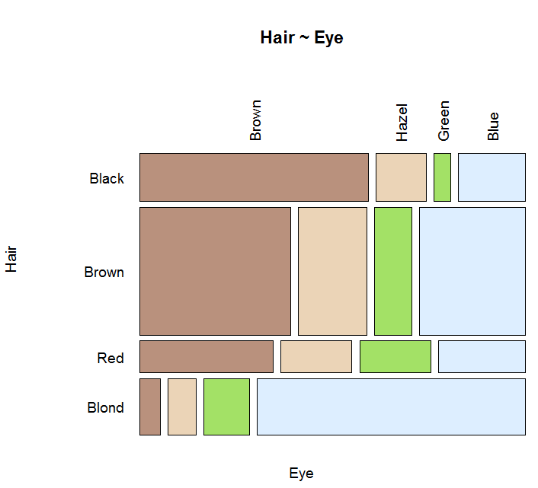 | PercTable(tab, freq=FALSE, rfrq="010")  ## Eye  ## Brown Hazel Green Blue  ## Hair  ## Black 63.0% 13.9% 4.6% 18.5%  ## Brown 41.6% 18.9% 10.1% 29.4%  ## Red 36.6% 19.7% 19.7% 23.9%  ## Blond 5.5% 7.9% 12.6% 74.0%  prop.table(margin.table(tab, 1))  ## Hair  ## Black Brown Red Blond  ## 0.1824 0.4831 0.1199 0.2145
Figure 10.1 Mosaicplot of Hair colour ~ Eye colour.

The plot makes the story quite visible! About half of the sample has brown hair, red is the less frequent hair colour observed (~5-10%). Within the black-haired people more than 50% have brown eyes. Blond people tend to have blue eyes. The percentage of green-eyed people is biggest within red haired guys, but with 20% not as pronounced as maybe expected. And so on.
The mosaicplot has an order. At first the hair colour is split and afterwards, within the single hair colour, the eye colour. This corresponds to a relationship Hair ~ Eye. If the inverse relation is the interesting one, the table can simply be transposed. This side of the coin then looks like (the colours are coding the dependent variable, here “Hair”):

cols <- SetAlpha(c("moccasin", "salmon1", "wheat3", "gray32"), 0.8)
PlotMosaic(tab, col=cols, main = "Hair ~ Eye", horiz = FALSE)

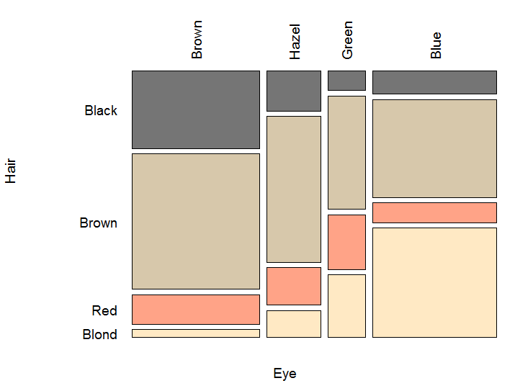  Figure 10.2 Mosaicplot of Eye colour ~ Hair colour. | PercTable(tab, freq=FALSE, rfrq="001")  ## Eye  ## Brown Hazel Green Blue  ## Hair  ## Black 30.9% 16.1% 7.8% 9.3%  ## Brown 54.1% 58.1% 45.3% 39.1%  ## Red 11.8% 15.1% 21.9% 7.9%  ## Blond 3.2% 10.8% 25.0% 43.7%  prop.table(margin.table(tab, 2))  ## Eye  ## Brown Hazel Green Blue  ## 0.3716 0.1571 0.1081 0.3632

Another – rather new – idea is to describe proportions in circles. It emphasises the association structure of the data. The left side of the circle represents the rows, say the hair colour, and the right one the columns, thus the eye colour. The advantage is that we see both marginal densities in the plot.

Eye  Hair  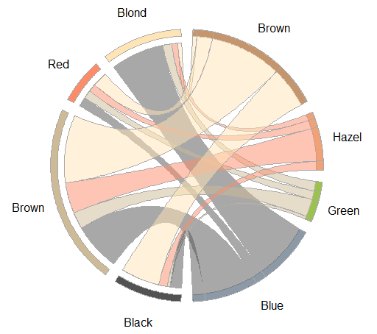  Figure 10.3 Circular plot of HairEyeColor. | cols <- c("moccasin", "salmon1",  "wheat3", "gray32",  "slategray1", "chartreuse3",  "burlywood", "sienna4")  PlotCirc  PlotCirc(t(tab), acol=cols)
Looking at the blue eyes first of all we notice, that roughly a third of the sample has blue eyes. Within those, about 40% have blond hair, 10% red hair, 40% brown hair and again 10% black hair. When we follow the band from the blue eyed to the blond haired, we notice that blue eyed people form ~75% of the blond-haired group.
Obviously, we see more (conditional) proportions in a circular plot than on a mosaic plot. A disadvantage is that angles are nowhere near as good to compare as the lengths in the mosaic.

Save
For saving the table, there’s the usual R-base command:
save
save(tab, file = "HairEyeColor.rda")

Descriptions, Statistics and Tests
Let’s create a 2-dimensional table and describe it with some bells and whistles. The argument verbose = high will maximize the volume of output:

# aggregate 3-d table to Eye and Hair colour only:
tab <- as.table(apply(HairEyeColor, c(2,3), sum))

# order the levels along colours:
tab <- tab[c("Brown","Hazel","Green","Blue"),]

# describe the table
Desc(tab, verbose="high")
## Summary:  ## n: 592, rows: 4, columns: 2  ##  ## Pearson's Chi-squared test:  ## X-squared = 1.5298, df = 3, p-value = 0.6754  ## Pearson's Chi-squared test (cont. adj):  ## X-squared = 1.5298, df = 3, p-value = 0.6754  ## Likelihood Ratio:  ## X-squared = 1.5294, df = 3, p-value = 0.6755  ## Mantel-Haenszel Chi-squared:  ## X-squared = 0.2438, df = 1, p-value = 0.6214 | Desc
The first line reports the total n in the table and the dimension, so we have 592 Persons in a table with 4 rows and two columns. Then several Chi-Square-tests are calculated. The null hypothesis is that the eye colour is not associated with the sex. The small value of the χ²-statistic, 1.5298, and the p-value of 0.6754 indicate that the null hypothesis can’t be rejected at the 0.05 level of significance. Thus, we would conclude that the observation does not indicate an association between eye colour and sex of the person.
The Pearson χ²-statistic involves the differences between the observed cell frequencies and the expected deviation-frequencies. Following a rule of thumb the expected frequency in every cell of the table should not be less than 5. R will print a message, if this condition is violated.
The continuity-adjusted χ²-test statistic consists of the Pearson χ² modified with an adjustment for continuity. As the sample size increases, the difference between the continuity-adjusted and Pearson χ² decreases. Thus, in very large samples (as we have here) the two statistics are almost the same. This test statistic is also an alternative to Pearson’s χ² if any of the expected values in a 2x2 table are less than 5. Some prefer to use the continuity-adjusted χ²-statistic when the sample size is small regardless of the expected values.

## Sex  ## Male Female Sum  ## Eye  ## Brown freq 98 122 220  ## perc 16.6% 20.6% 37.2%  ## p.row 44.5% 55.5% .  ## p.col 35.1% 39.0% .  ##  ## Hazel freq 47 46 93  ## perc 7.9% 7.8% 15.7%  ## p.row 50.5% 49.5% .  ## p.col 16.8% 14.7% .  ##  ## Green freq 33 31 64  ## perc 5.6% 5.2% 10.8%  ## p.row 51.6% 48.4% .  ## p.col 11.8% 9.9% .  ##  ## Blue freq 101 114 215  ## perc 17.1% 19.3% 36.3%  ## p.row 47.0% 53.0% .  ## p.col 36.2% 36.4% .  ##  ## Sum freq 279 313 592  ## perc 47.1% 52.9% 100.0%  ## p.row . . .  ## p.col . . . | 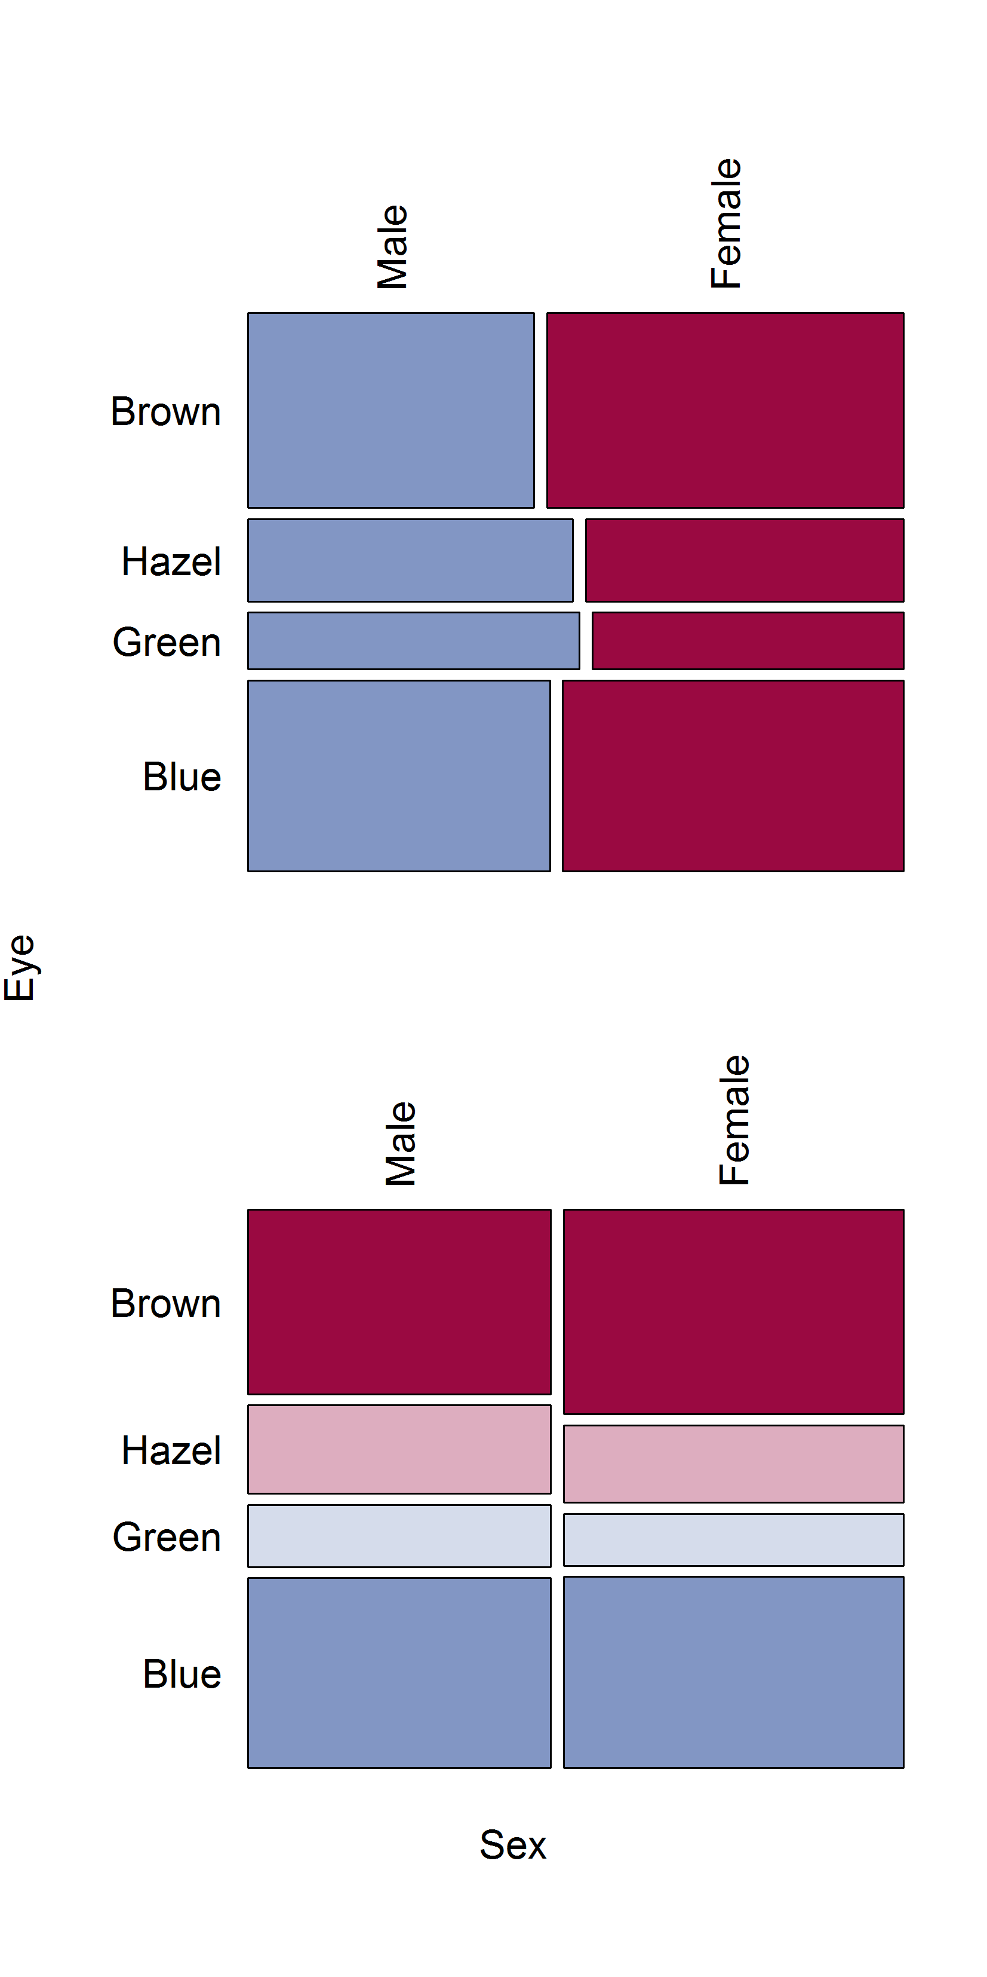

The expected frequencies can be obtained by using the expected option on the Desc command (Desc(tab, verbose="high", expected=TRUE)).
Additionally, the difference between the observed cell count and the expected cell count will be reported when using the residuals=TRUE and stdres=TRUE option for the standardized residuals (amount that each cell contributes to the value of the test statistic).

options(fmt.num=structure(list(digits=3), class="fmt"))
PercTable,
ExpFreq
PercTable(tab, freq=TRUE, rfrq="000",
expected=TRUE, residuals=TRUE)

## Sex  ## Male Female  ## Eye  ## Brown freq 98 122  ## exp 103.682 116.318  ## res -0.558 0.527  ##  ## Blue freq 101 114  ## exp 101.326 113.674  ## res -0.032 0.031 | ## Hazel freq 47 46  ## exp 43.829 49.171  ## res 0.479 -0.452  ##  ## Green freq 33 31  ## exp 30.162 33.838  ## res 0.517 -0.488

This output shows the observed frequencies (freq), the expected values (exp) and the Pearson residuals (res), whose squared values are each cell’s contribution to the χ² statistic. None of the expected values are less than 5, so we feel comfortable with the result of the Chi-Square test above.

The Likelihood Ratio χ² is asymptotically equivalent to the Pearson χ² (and Mantel-Haenszel χ²) but not usually used when analyzing 2x2 tables. It is used in logistic regression and loglinear modeling which involves contingency tables.

The Mantel-Haenszel χ² is related to the Pearson χ² and, in the 2x2 case, as the sample size gets large these statistics converge. In the case of 2xC or Rx2 tables, if the variable with more than 2 categories is ordinal, the Mantel-Haenszel χ² is a test for trend while the Pearson χ² remains a general test for association.

When the verbose argument of the function Desc is set to "high", several statistics that describe the nominal and ordinal association between the two variables of the contingency table will be computed.

## estimate lwr.ci upr.ci
## Phi Coeff. 0.0508 - -
## Contingency Coeff. 0.0508 - -
## Cramer V 0.0508 0.0000 0.1076

The phi coefficient is a measure of the degree of association between two categorical variables and is interpretable as a correlation coefficient. It is derived from the χ²-statistic but is free of the influence of the total sample size (Fleiss, 1981). Being independent of the sample size is a desirable quality because the χ²-statistic itself is sensitive to sample size. As the sample size increases, the χ² value will increase even if the cell proportions remain unchanged.
Pearson’s contingency coefficient and Cramer’s V are also derived from the chi-square and in the 2x2 table they are identical to the Phi coefficient (and similar to the Phi coefficient in interpretation). These three measures of degree of association are well suited for nominal variables in which the order of the levels is meaningless.

Cramer’s V is useful for comparing multiple χ² test statistics and is generalizable across contingency tables of varying sizes. It is not affected by sample size and therefore is very useful in situations, where a statistically significant test result is suspected to be the result of a large sample size instead of any substantive relationship between the variables. It is interpreted as a measure of the relative strength of an association between two variables. It goes from 0 to 1, where 1 indicates strong association. In 2x2-tables the range is -1 to 1. The value of 0.0508 shows a very small, resp. no association between sex and hair colour at all.

The following are measures of ordinal association that consider whether the variable Y tends to increase as X increases: Gamma, Kendall’s tau-b, Stuart’s tau-c, and Somers’ D. These measures are appropriate for ordinal variables, and they classify pairs of observations as concordant or discordant. A pair is concordant if the observation with the larger value of X also has the larger value of Y. A pair is discordant if the observation with the larger value of X has the smaller value of Y. Refer to Agresti (1996) and the other references cited in the discussion of each measure of association.
(We switch the example here, because our HairEyeColour variables aren’t ordinal.)

(job <- matrix(c(16,19,9,8,17,11,14,60,56), nrow=3,
dimnames=list("satisfaction"=c("high","medium","low"),
"security"=c("high","medium","low"))))
## security
## satisfaction high medium low
## high 16 8 14
## medium 19 17 60
## low 9 11 56

Desc(job, verbose="high")
##
## estimate lwr.ci upr.ci
... (output skipped)
## Goodman Kruskal Gamma 0.3960 0.2103 0.5817
## Kendall Tau-b 0.2405 0.1206 0.3603
## Stuart Tau-c 0.2106 0.1038 0.3174
## Somers D C|R 0.2238 0.1123 0.3354
## Somers D R|C 0.2583 0.1242 0.3924
## Pearson Correlation 0.2742 0.1442 0.3950
## Spearman Correlation 0.2633 0.1327 0.3850
... (output skipped)

Gamma is recommended when there are lots of ties in the data. Tau-b is recommended for square tables.

The Pearson correlation coefficient and the Spearman rank correlation coefficient are also appropriate for ordinal variables. The Pearson correlation describes the strength of the linear association between the row and column variables, and it is computed using the row and column scores specified. The Spearman correlation is computed with rank scores.
The polychoric correlation is not reported but can be calculated with the function CorPolychor. It also requires ordinal variables and assumes that the variables have an underlying bivariate normal distribution.

The measures of association lambda and uncertainty coefficient do not require ordinal variables, but they are appropriate for nominal variables.
Lambda has another concept than chi-squares. With Lambda the proportional reduction in error will be calculated. Lambda allows deciding, if the prediction of a class can be improved by using the other variable.

Desc(apply(Titanic, c(2,4), sum), verbose="high", rfrq="000")
## ------------------------------------------------------------------------------
... (output skipped)

## estimate lwr.ci upr.ci
... (output skipped)
## Lambda C|R 0.3066 0.2568 0.3564
## Lambda R|C 0.0000 0.0000 0.0000
## Lambda sym 0.1846 0.1546 0.2146
## Uncertainty Coeff. C|R 0.1569 0.1283 0.1854
## Uncertainty Coeff. R|C 0.1903 0.1570 0.2237
## Uncertainty Coeff. sym 0.1720 0.1414 0.2026
## Mutual Information 0.1424 - -
##
## Survived
## No Yes Sum
## Sex
## Male 1'364 367 1'731
## Female 126 344 470
## Sum 1'490 711 2'201

Without information about the sex, the best prediction for surviving would be “No”. We would guess 2201-1490=711 FALSE (Error E1=711) and 1490 correct. Using the variable sex we would guess survived “Yes” for women and “No” for men. So we would guess correct 344 women and 1364 men and 126 women and 367 men not correct (leading to an error E2=126+367=493). Lambda is then calculated as
The (C|R) notation indicates that the column variable is to be predicted by using the row variable. Thus, using the variable Sex (row-variable R) we make 30% less errors in predicting Survival of Titanic disaster (column variable C).
Note that we would not profit by the variable survived to predict the sex of a person, as the according lambda value R|C is 0.

Asymptotic confidence limits for all statistics are computed. The confidence coefficient is determined according to the value of the conf.level option, which by default equals 0.95 and produces 95% confidence limits.

Cases
The following cases are taken more or less verbatim from the SAS-Freq documentation^{[4]} and recalculated with base R and specific DescTools functions. The comments and descriptions have partly been adopted.

Eye colour - Binomial Proportions for One-Way Frequency Tables
The binomial proportions are computed as the proportion of observations for all the levels of the variable. The following statements compute the proportion of children with brown eyes (from the data set in Example 28.1 on page 1335) and test this value against the hypothesis that the proportion is 50%. Also, these statements test whether the proportion of children with fair hair is 28%.

tab <- as.table(apply(HairEyeColor, 2, sum)[c("Brown","Hazel","Green","Blue")])
Desc(tab)

## ------------------------------------------------------------------------------
## tab (table)
##
## Summary:
## n: 592, rows: 4
##
## Pearson's Chi-squared test (1-dim uniform):
## X-squared = 133.47, df = 3, p-value < 2.2e-16
##
## level freq perc cumfreq cumperc
## 1 Brown 220 37.2% 220 37.2%
## 2 Hazel 93 15.7% 313 52.9%
## 3 Green 64 10.8% 377 63.7%
## 4 Blue 215 36.3% 592 100.0%

xci <- BinomCI(tab, sum(tab))
rownames(xci) <- rownames(tab)
print(xci, digits=3)

## est lwr.ci upr.ci
## Brown 0.372 0.3336 0.411
## Hazel 0.157 0.1300 0.189
## Green 0.108 0.0856 0.136
## Blue 0.363 0.3254 0.403
PlotDot

Let’s produce a plot of that:

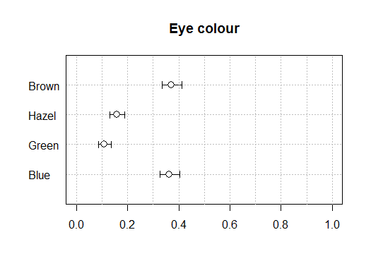 | PlotDot(xci[,1], main="Eye colour", pch=NA,  args.errbars = list(  from=xci[,2], to=xci[,3],  mid=xci[,1], pch=21, cex=1.4),  xlim=c(0,1))  abline(v=seq(0,1,0.1), col="grey", lty="dotted")
Figure 13.1 Dotplot of marginal proportions for eye colour.

The estimation of simultaneously calculated confidence intervals for multinomial proportions according to the method of Sison and Glaz leads to slightly broader confidence intervals especially for the smaller groups (Hazel, Green).

print(MultinomCI(tab), digits=3)

## est lwr.ci upr.ci
## Brown 0.372 0.3294 0.415
## Hazel 0.157 0.1149 0.201
## Green 0.108 0.0659 0.152
## Blue 0.363 0.3209 0.407

Cochran-Armitage Trend Test
In clinical trials, a dose response study is often conducted to investigate the relationship between increasing dosage and the effect of the drug under study. Usually the dose levels tested are ordinal, and the effect of the drug is measured in binary. In this case, Cochran-Armitage trend test is frequently used to test for trend among binomial proportions.

d.lungtumor <- data.frame(dose = rep(c(0, 1, 2), c(40, 50, 48)),
tumor = c(rep(c(0, 1), c(38, 2)),
rep(c(0, 1), c(43, 7)),
rep(c(0, 1), c(33, 15))))
lung <- table(d.lungtumor$dose, d.lungtumor$tumor)
Desc(lung, rfrq="010")

... (output skipped)
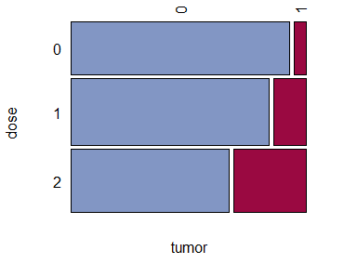
## tumor
## 0 1 Sum
## dose
##
## 0 freq 38 2 40
## p.row 95.0% 5.0% .
##
## 1 freq 43 7 50
## p.row 86.0% 14.0% .
##
## 2 freq 33 15 48
## p.row 68.8% 31.2% .
##
## Sum freq 114 24 138
## p.row . . .
Figure 13.2 Lung cancer proportions.

Cochran
ArmitageTest
CochranArmitageTest(lung, alternative = "increasing")

## Cochran-Armitage test for trend
##
## data: lung
## Z = -3.2735, dim = 3, p-value = 0.0005311
## alternative hypothesis: increasing

The Cochran-Armitage test supports the trend hypothesis. The small right-sided p-value (alternative = “increasing”) indicate that the probability of the column 1 level (lungtumor = 1) increase as dose increases.

Heart – 2x2-Table
This example computes chi-square tests and Fisher’s exact test to compare the probability of coronary heart disease for two types of diet. It also estimates the relative risks and computes exact confidence limits for the odds ratio.
The data set contains hypothetical data for a case-control study of high fat diet and the risk of coronary heart disease. The data can be entered as:

heart <- as.table(matrix(c(11, 2, 4, 6), nrow=2,
dimnames = list(Exposure = c("High", "Low"),
Response = c("Yes", "No"))))
Label(heart) <- "Table of Response by Exposure"

The data is sorted in descending order by both variables, Exposure and Response, so that the first cell of the 2x2-table contains the frequency of positive exposure and positive response.

Desc(heart, main="Case-Control Study of High Fat/Cholesterol Diet")

will produce the following result:

## Case-Control Study of High Fat/Cholesterol Diet
## Table of Response by Exposure
##
##
## Summary:
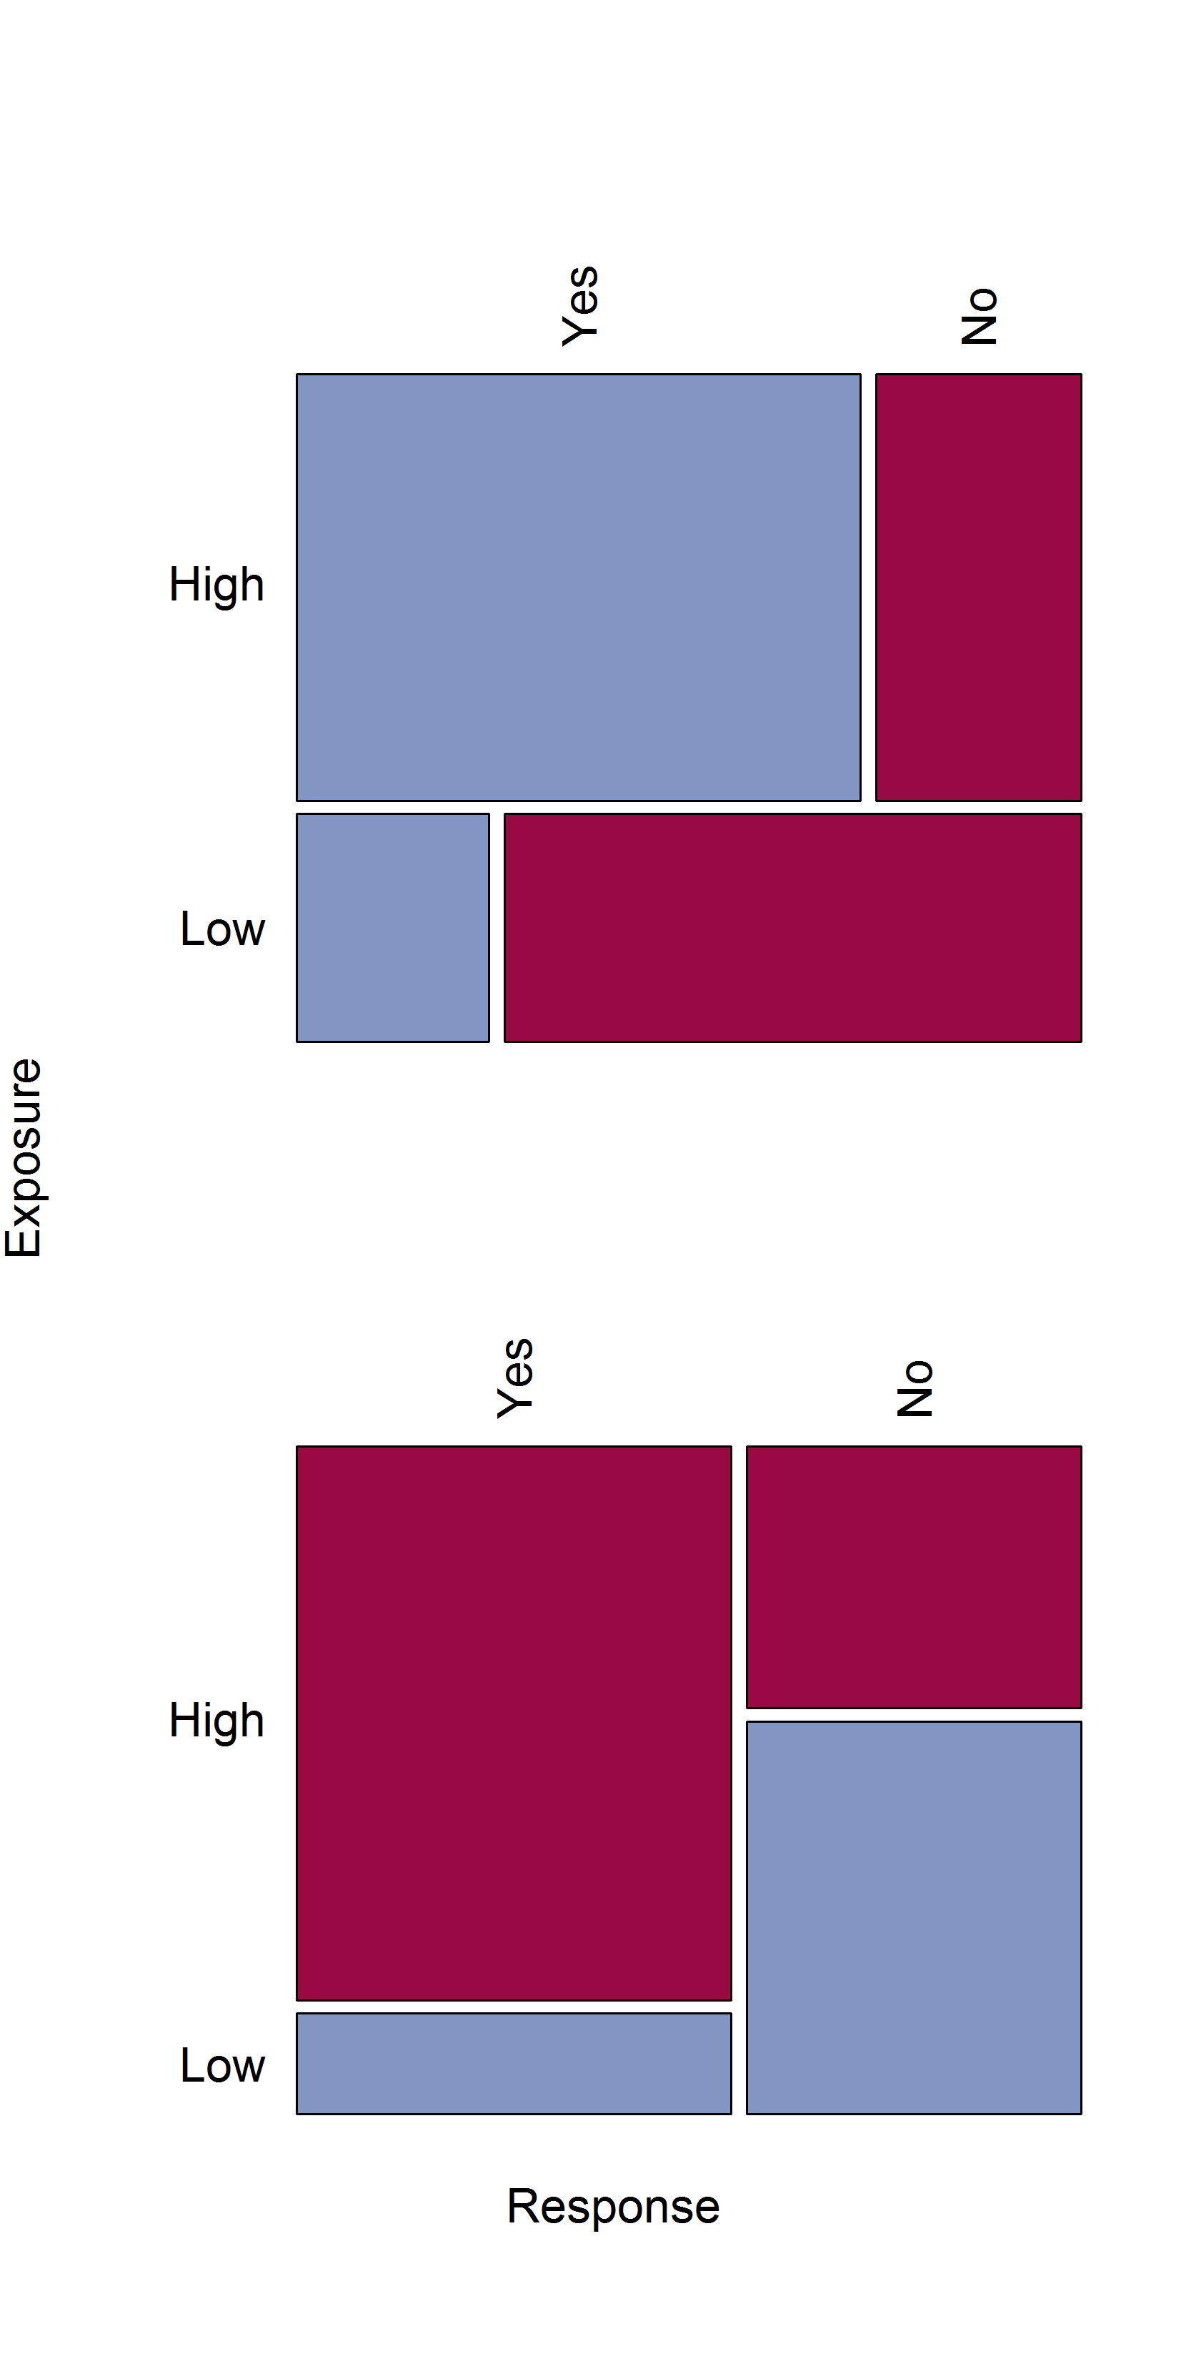
## n: 23, rows: 2, columns: 2
##
## Pearson's Chi-squared test (cont. adj):
## X-squared = 3.1879, df = 1, p-value = 0.07418
## Fisher's exact test p-value = 0.03931
## McNemar's chi-squared = 0.16667, df = 1,
## p-value = 0.6831
##
## Warning message:
## Exp. counts < 5: Chi-squared approx. may
## be incorrect!!
##
## estimate lwr.ci upr.ci
##
## odds ratio 8.250 1.154 59.003
## rel. risk (col1) 2.933 0.850 10.120
## rel. risk (col2) 0.356 0.140 0.901
##
## Phi-Coefficient 0.464
## Contingency Coeff. 0.421
## Cramer's V 0.464
##
## Response
## Yes No Sum
## Exposure
## High freq 11 4 15
## perc 47.8% 17.4% 65.2%
## p.row 73.3% 26.7% .
## p.col 84.6% 40.0% .
##
## Low freq 2 6 8
## perc 8.7% 26.1% 34.8%
## p.row 25.0% 75.0% .
## p.col 15.4% 60.0% .
##
## Sum freq 13 10 23
## perc 56.5% 43.5% 100.0%
## p.row . . .
## p.col . . .
##

We learn that we have a total of 23 persons in our dataset and that the table has two rows and 2 columns. The association between the response and exposure appears not be existent, as the chi-square test is not significant (p = 0.0741).
However, if the expected value of one or more cells is less than 5, the chi-square test may not be valid. A specific warning indicates that this is here the case. Fisher’s exact test is an alternative test which does not depend on the expected values and is the appropriate test in this situation. It analyses whether the probability of heart disease in the high fat group differs from the one in the low-fat group; since this p-value is small (p < 0.05), the alternative hypothesis is supported. Note that only the one-sided test will be reported.

The function expects the table to have the risk factor in rows and the response or outcome in the columns. The positive risk factor is preferred to be in the first row and the positive response in the first column:

Risk factor | Response
Risk factor | Yes | No
Yes | A | B
No | C | D

The odds ratio is then defined as
Recall that the odds of an event occurring is the ratio of p/q where p is the probability of the event occurring and q is the probability of the event not occurring. The odds ratio provides in fact an estimate of the relative risk when an event is rare (which here is not the case!).
The estimate indicates that the odds of heart disease are 8.25 times higher in the high fat diet group; however, the wide confidence limits (1.154, 59.003) indicate that this estimate has low precision.

The relative risk is the ratio of the probability of the heart disease occurring in the risk group (high fat diet) to the probability of the heart disease occurring in the comparison, non-exposed group (low fat diet). This is reported as rel. risk (col1) in the output above.
A relative risk greater than 1 indicates that the probability of positive response is greater (here: heart disease) in row 1 (here: high fat diet group) than in row 2 (here: low fat diet group). Similarly, a relative risk less than 1 would indicate that the probability of positive response is less in row 1 than in row 2. The strength of association increases with the deviation from 1.

The relative risk column 2 uses the observations in this column to calculate the ratio.
Recall an incidence rate is the proportion of new cases (outcomes) occurring over a period of any one time. Therefore, the risk of an outcome makes sense in the context of prospective cohort studies where the outcome has not occurred in any case at the start of the study.
While the relative risk RR is a measure which is appropriate for prospective cohort studies, the odds ratio OR can be used for crosssectional case-control studies as well as prospective studies. In both cases, a value of 1 indicates no difference between groups.

Interchanging the row and column variables or modifying the table order will result in different values of odds ratio and relative risks. Reversing the columns for instance will result in the reciprocal OR:

OddsRatio(heart)
## [1] 8.25

1 / OddsRatio(Rev(heart, 1))
## [1] 8.25

The interpretations should however remain consistent.

Skin - Agreement Study
Medical researchers are interested in evaluating the efficacy of a new treatment for a skin condition. Dermatologists from participating clinics were trained to conduct the study and to evaluate the condition. After the training, two dermatologists examined patients with the skin condition from a pilot study and rated the same patients. The possible evaluations are terrible, poor, marginal, and clear.
In order to evaluate the agreement of the diagnoses (a possible contribution to measurement error in the study), the kappa coefficient is computed.

ParseSASDatalines("
data d.SkinCondition;
input Derm1 $ Derm2 $ Count;
datalines;
terrible terrible 10 terrible poor 4 terrible marginal 1 terrible clear 0
poor terrible 5 poor poor 10 poor marginal 12 poor clear 2
marginal terrible 2 marginal poor 4 marginal marginal 12 marginal clear 5
clear terrible 0 clear poor 2 clear marginal 6 clear clear 13
;")
skin <- xtabs(Count ~ ., d.SkinCondition)

The function Agree computes raw simple percentage agreement among raters.

Agree(Untable(skin))

## [1] 0.5113636
## attr(,"subjects")
## [1] 88
## attr(,"raters")
## [1] 2

We learn that 51.1% of the ratings were the same between the two researchers. A less coarse approach to measure agreement is Cohen’s kappa.

CohenKappa(skin, conf.level=0.95)
CohenKappa

## kappa lwr.ci upr.ci
## 0.3448753 0.2048513 0.4848994

CohenKappa(skin, conf.level=0.95, weights="Fleiss-Cohen")
## kappa lwr.ci upr.ci
## 0.6607229 0.4207465 0.9006993

The kappa coefficient has the value 0.3449, which indicates slight agreement between the dermatologists. The conclusion to reject the null hypothesis of no agreement is supported by the confidence interval of (0.2030, 0.4868), which suggests that the true kappa is greater than zero. The weighted kappa coefficient can be calculated by defining the weights argument. Its value is even larger (0.6607) than the unweighted kappa.
The Bowker’s test for symmetry (reported by mcnemar.test) is not defined here (because of the zeros in the table).

Migraine - Statistics for a Stratified 2x2-Table
The data set Migraine contains hypothetical data for a clinical trial of migraine treatment. Subjects of both genders receive either a new drug therapy or a placebo. Their response to treatment is coded as ’Better’ or ’Same’. The data are recorded as cell counts, and the number of subjects for each treatment and response combination is recorded in the variable Count. The following statements create a three-way table stratified by Gender, where Treatment forms the rows and Response forms the columns.

ParseSASDatalines("
data d.Migraine;
input Gender $ Treatment $ Response $ Count @@;
datalines;
female Active Better 16 female Active Same 11
female Placebo Better 5 female Placebo Same 20
male Active Better 12 male Active Same 16
male Placebo Better 7 male Placebo Same 19
;
")
migraine <- xtabs(Count ~ Treatment + Response + Gender, d.Migraine)

How does this look like?

ftable(migraine, col.vars = c(1,3))

## Treatment Active Placebo
## Gender female male female male
## Response
## Better 16 12 5 7
## Same 11 16 20 19

It’s always a good idea to have a plot of the situation:

d.frm <- as.data.frame(prop.table(migraine, c(2,3)))
d.frm$Treatment <- reorder.factor(d.frm$Treatment, new.order = c("Placebo","Active"))
d.frm$Response <- reorder.factor(d.frm$Response, new.order = c("Same","Better"))

library(lattice)
barchart
barchart(Freq ~ Response | Treatment + Gender, data=d.frm,
col="steelblue",
panel = function(x, ...) {
panel.grid(h=-1, v=0)
panel.barchart(x, ...)
},
par.settings = list(strip.background=list(col="lightgrey"),
layout.heights=list(strip=1.45)),
par.strip.text = list(col="black"),
layout=c(2,2), cex.axis=2, ylim=c(0,1), xlab="Response", ylab="Percent",
scales=list(tck=c(0.8,0.8), col="black", x=list(cex=1), y=list(cex=1)),
main="Migraine")

This code yields:
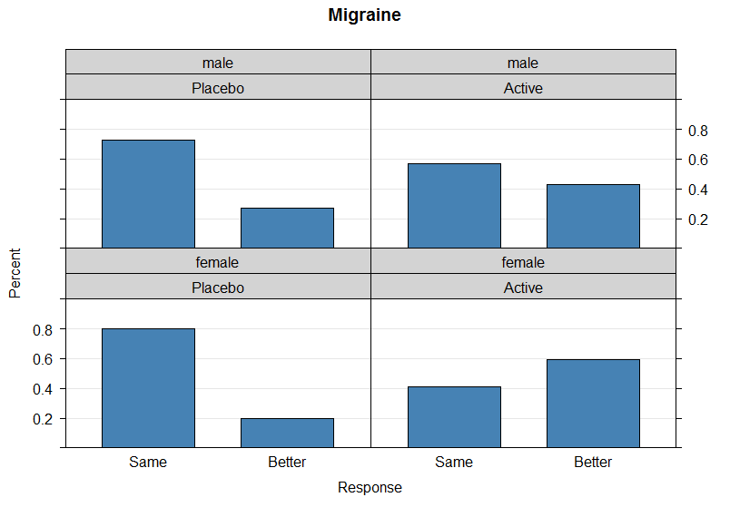
Figure 13.3 Trellis barplot of migraine patients.

The percentages are calculated so, that every panel has a total of 100%:

ptab <- prop.table(migraine, c(2,3))
ptab[] <- Format(ptab, digits=1, fmt="%")
ptab

## , , Treatment = Active  ## Gender  ## Response female male  ## Better 59.3% 42.9%  ## Same 40.7% 57.1% | ##, , Treatment = Placebo  ##  ## Gender  ## Response female male  ## Better 20.0% 26.9%  ## Same 80.0% 73.1%

Apparently the treatment seems to have an obvious effect. But the plot seems as well to indicate a gender effect, as the treatment is more pronounced for women than for men.

The function mantelhaen.test produces the Cochran-Mantel-Haenszel statistics. For this stratified 2x2 table, an estimate of the common odds ratio including its confidence interval is also displayed. (Note that the function expects the third dimension to be the strata, here gender.)

mantelhaen.test(migraine, alternative = "two.sided", correct = FALSE)
mantelhaen.test

## Mantel-Haenszel chi-squared test without continuity correction
##
## data: migraine
## Mantel-Haenszel X-squared = 8.3052, df = 1, p-value = 0.003953
## alternative hypothesis: true common odds ratio is not equal to 1
## 95 percent confidence interval:
## 1.445613 7.593375
## sample estimates:
## common odds ratio
## 3.313168

The significant p-value (0.004) indicates that the association between treatment and response remains strong after adjusting for gender.

A table of relative risks can be produced with

apply(migraine, 3, function(x) list(rbind(
"Case-control (odds ratio)" = OddsRatio(x, conf.level = 0.95),
"Cohort (col1 risk)" = RelRisk(x, conf.level = 0.95),
"Cohort (col2 risk)" = RelRisk(Rev(x, 1), conf.level = 0.95))))

## $female
## $female[[1]]
## odds ratio lwr.ci upr.ci
## Case-control (odds ratio) 5.818182 1.6755251 20.2033617
## Cohort (col1 risk) 2.962963 1.3713759 7.0036872
## Cohort (col2 risk) 0.337500 0.1427819 0.7291947
##
## $male
## $male[[1]]
## odds ratio lwr.ci upr.ci
## Case-control (odds ratio) 2.0357143 0.6477707 6.397531
## Cohort (col1 risk) 1.5918367 0.7662184 3.454346
## Cohort (col2 risk) 0.6282051 0.2894904 1.305111

Because this is a prospective study, the relative risk estimate assesses the effectiveness of the new drug; the “Cohort (col1 risk)” values are the appropriate estimates for the first column, or the risk of improvement. The probability of migraine improvement with the new drug is just over two times the probability of improvement with the placebo.

The function mantelhaen.test displays also an estimate of the common odds ratio. This figure is calculated as [Agresti, p. 234]:

sum(apply(migraine, 3, function(x) prod(diag(x))/sum(x))) /
sum(apply(migraine, 3, function(x) prod(diag(Rev(x, 1)))/sum(x)))

## 3.313168

The Breslow-Day test for homogeneity of the odds ratios can be calculated with the eponymous function. It tests the null hypothesis that the odds ratios for the q strata are all equal.

BreslowDayTest(migraine)
BreslowDayTest

## Breslow-Day Test on Homogeneity of the Odds Ratios
##
## data: migraine
## X-squared = 1.4965, df = 1, p-value = 0.2212

The large p-value (0.2212) indicates no significant gender difference in the odds ratios.
Had the test for homogeneity of the odds ratios been statistically significant, a closer examination of each 2x2 table at each strata of the stratification variable would be required before making any further interpretations or conclusions.

Caution: Unlike the Cochran-Mantel-Haenszel statistics, the Breslow-Day test requires a large sample size within each stratum, and this limits its usefulness. In addition, the validity of the Cochran-Mantel-Haenszel tests does not depend on any assumption of homogeneity of the odds ratios; therefore, the Breslow-Day test should never be used as such an indicator of validity.

Homogeneity could also be assessed using Woolf's test.
WoolfTest
WoolfTest(migraine)

## Woolf-test on Homogeneity of Odds Ratios (no 3-Way assoc.)
##
## data: migraine
## X-squared = 1.4808, df = 1, p-value = 0.2236

Here the Woolf gives almost equivalent results to the BreslowDay test for consistency for the odds ratio.

The odds ratio for the treatment is

tab <- t(apply(migraine, c(1,2), sum))
OddsRatio(tab, conf.level = 0.95)

## odds ratio lwr.ci upr.ci
## 3.370370 1.461559 7.772108

References
- Agresti A. (2002) Categorical Data Analysis. John Wiley & Sons.
- Dalgaard P. (2008) Introductory Statistics with R (2. Aufl.), London, UK: Springer.
- Friendly M. (2013) Working with categorical data with R and the vcd and vcdExtra packages, York University, Toronto.
http://cran.r-project.org/web/packages/vcdExtra/vignettes/vcd-tutorial.pdf
- One-Way Frequency Tables using SAS PROC FREQ © TexaSoft, 2006 http://www.stattutorials.com/SAS/TUTORIAL-PROC-FREQ-1.htm
- Presnell B. (2011) Course Notes sta4504-2011sp, http://www.stat.ufl.edu/~presnell/Courses/sta4504-2011sp/Notes/icda-notes-3x2.pdf
- SAS/STAT® 9.2 User’s Guide, Second Edition, The FREQ Procedure (Book Excerpt) (2009) http://support.sas.com/documentation/cdl/en/statugfreq/63124/PDF/default/statugfreq.pdf

